DevOps Lab 2: Deploy an application to an EC2 fleet using AWS CodeDeploy

Objectives according to Lab:

1. Make systematic deployments to a fleet of EC2 servers using CodeDeploy.
2. Verify if the CodeDeploy agent is installed and running on a Windows server.
3. Create a deployment application and group in CodeDeploy.
4. Review and prepare a deployment package to be installed by CodeDeploy.
5. Monitor deployment status in CodeDeploy and deployment targets.

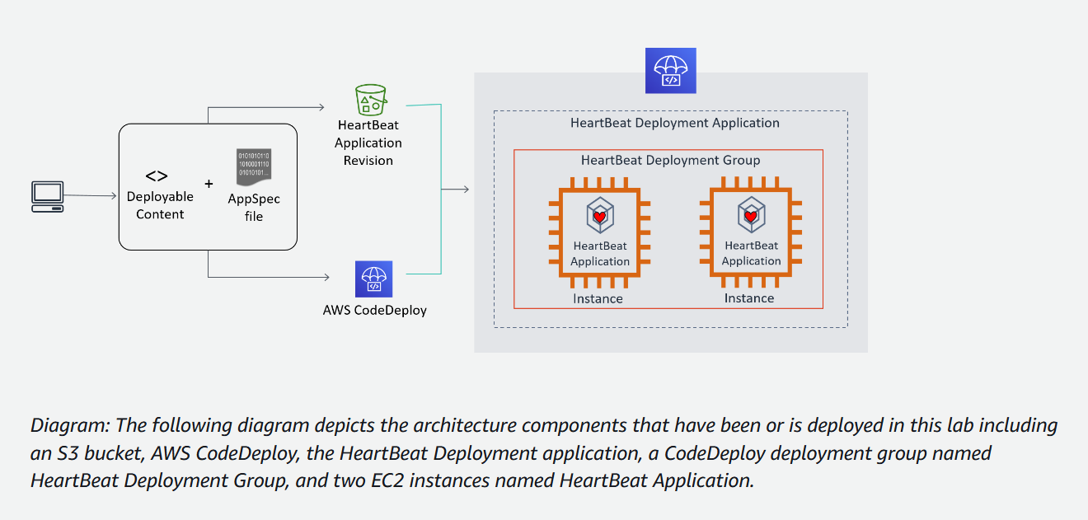

* S3 - Stores code and data for Heartbeat application
* HeartBeat Deployment Application: This is the application that is being deployed.

(more like a function to send heartbeat signals at regular intervals)

* CodeDeploy Deployment Group: A deployment group is a logical collection of instances that CodeDeploy will deploy the application to. In this case, the deployment group is named “HeartBeat Deployment Group”.
* EC2 Instances: These are the Amazon Elastic Compute Cloud (EC2) instances that the application is being deployed to.

Objective 1:

Review EC2 Servers

1.1 Select EC2, and view running instances

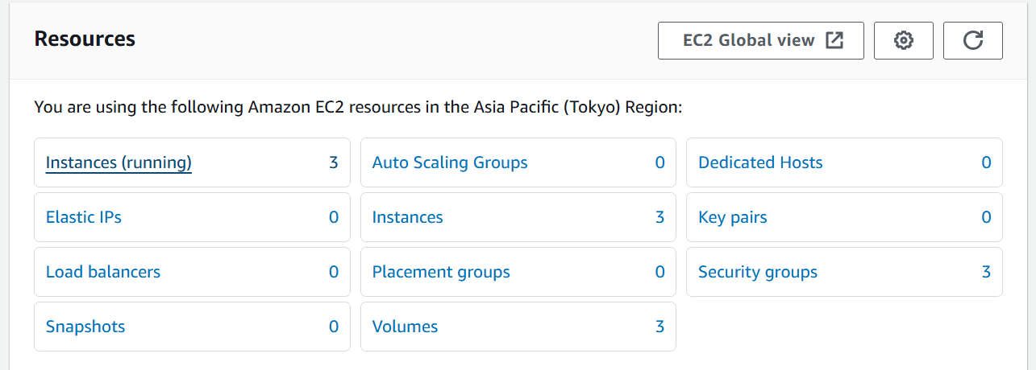

1.2 Two Heartbeat instances running, verified

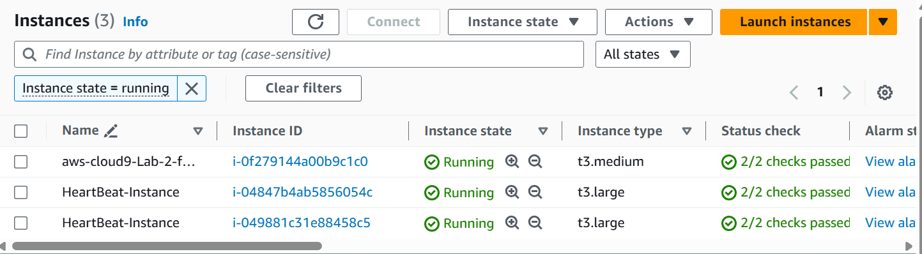

Objective 2

Review CodeDeploy

ELI5:

CodeDeploy is like a special delivery system for software. It takes your application code and makes sure it gets safely and efficiently delivered to all the computers or servers where you want it to run. Whether you have just one server or hundreds, CodeDeploy helps you manage the process of getting your software up and running smoothly.

2.1 Choose one HB instance, and select Connect

|||||||

V

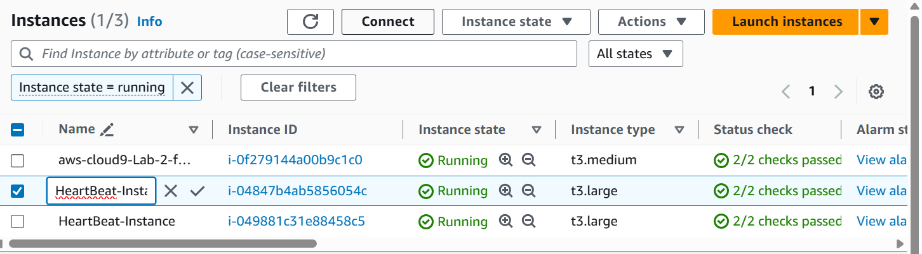

2.2 In the CLI window, enter the following command



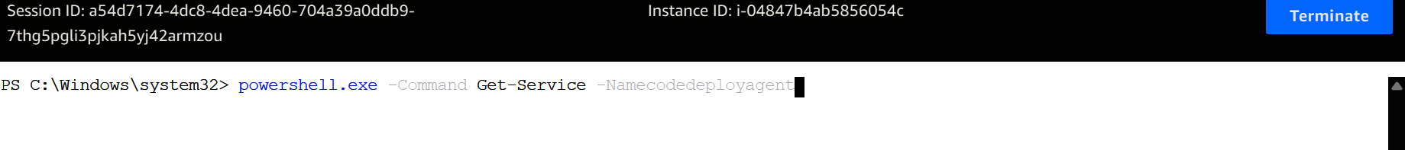

Output: Verified

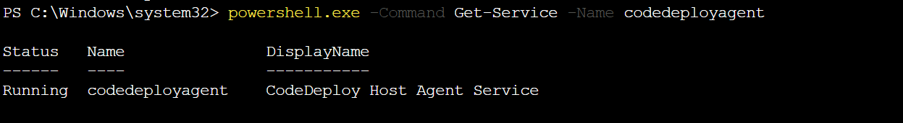

Objective 3:

REVIEW PERMISSIONS FOR CODEDEPLOY

3.1 Open IAM section and select Roles in left pane

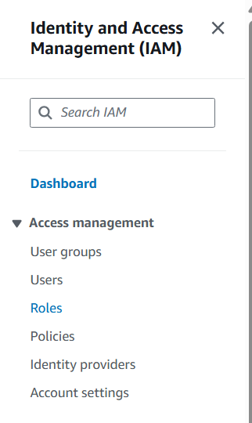

3.2 Open **CodeDeployServiceRole**

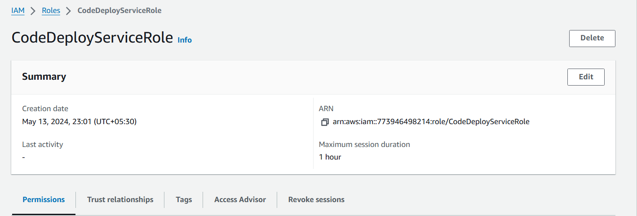

3.3 Verify Permissions and if “managed policy” is attached to it

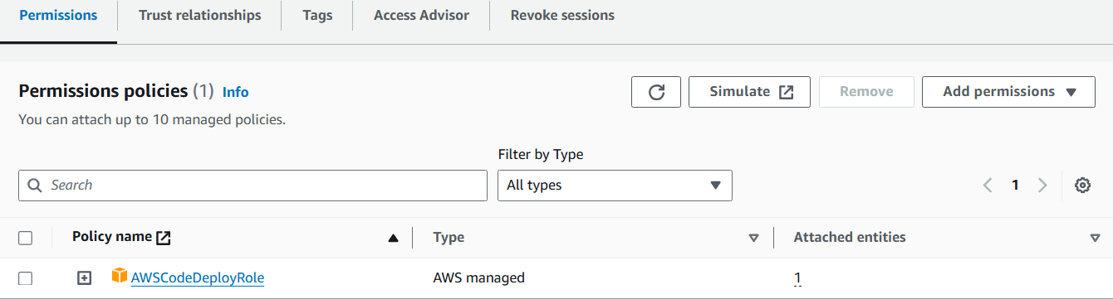

The policy which has been attached:  
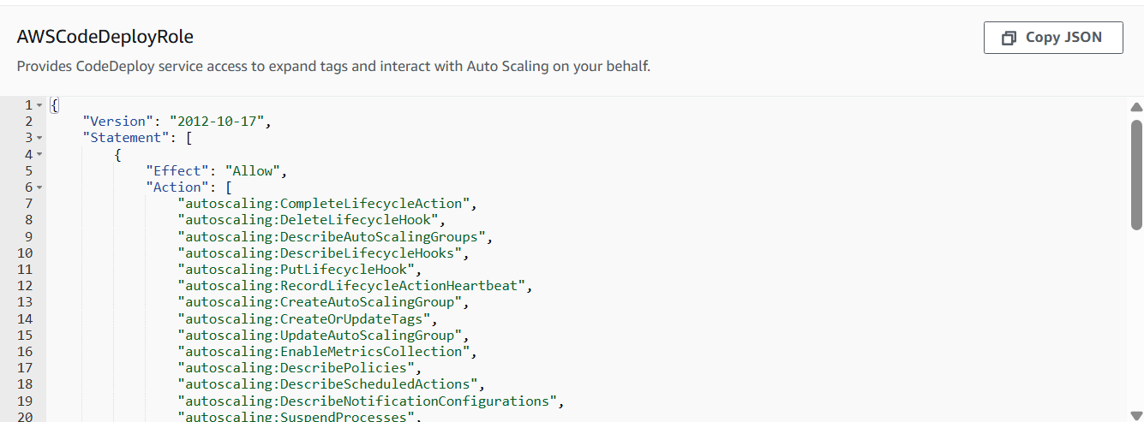

Objective 4 - Create CodeDeploy Application and Deployment Group

4.1 Open CodeDeploy in AWS console and open Applications, from left pane

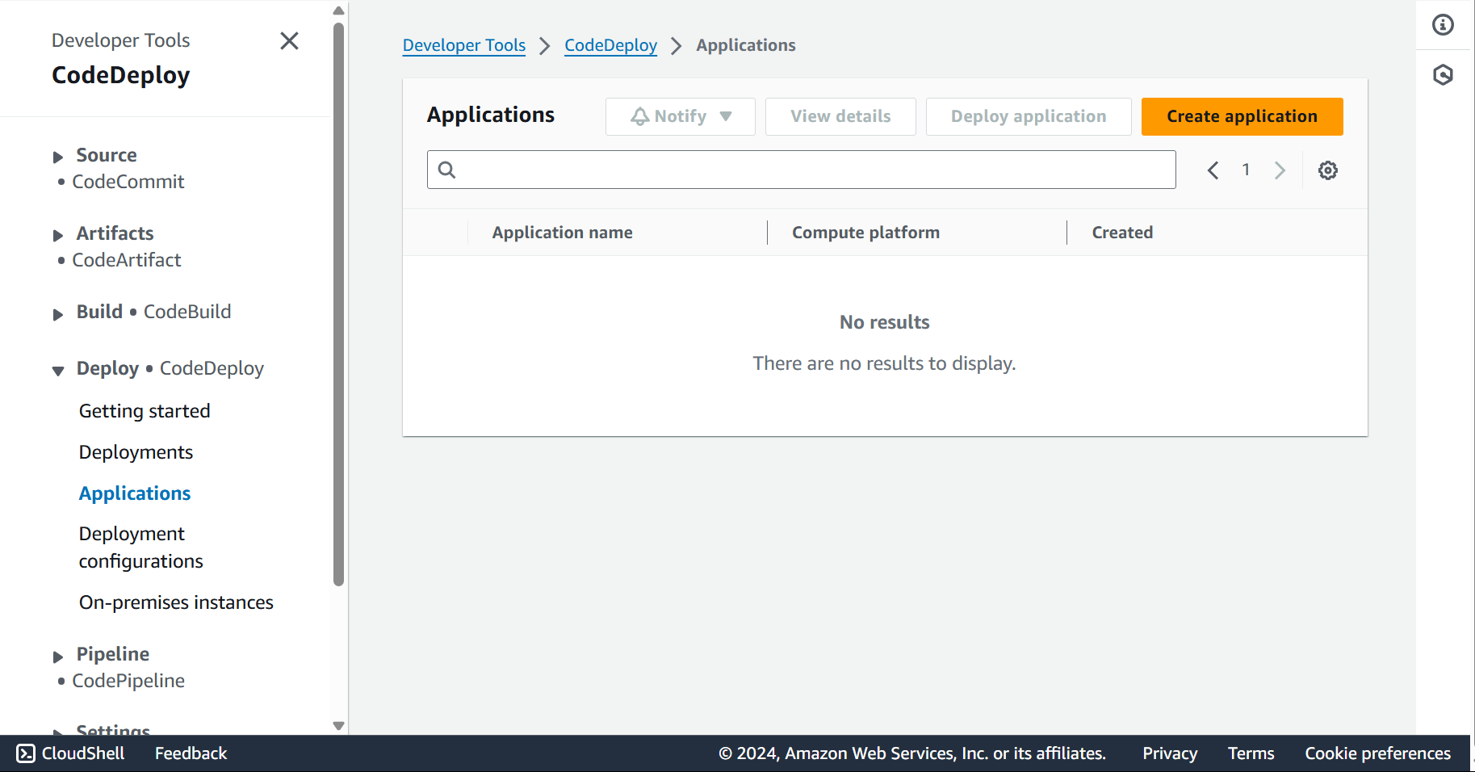

4.2 Create a platform with following specs:

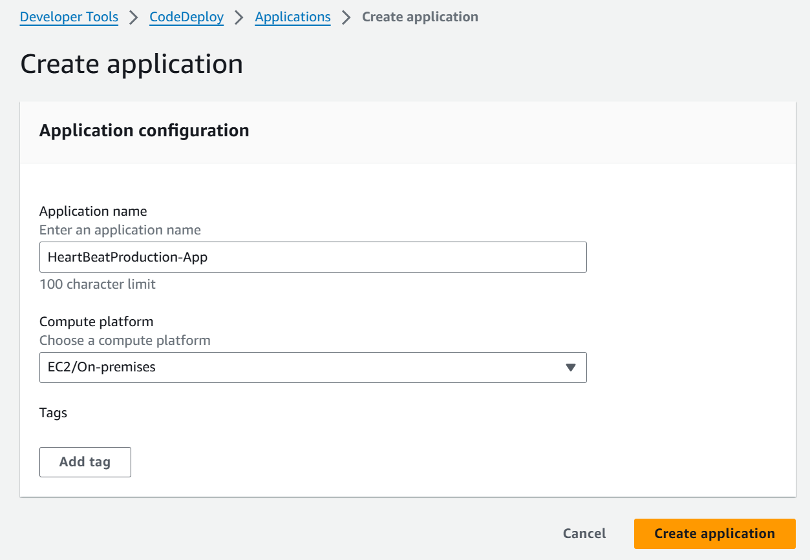

4.3 Choose Create Dep. Group option

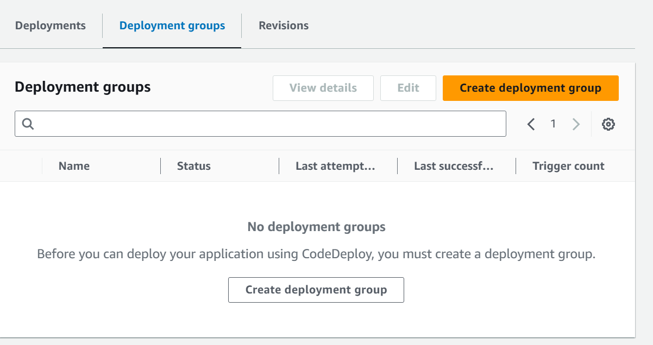

4.4 Select/fill these values

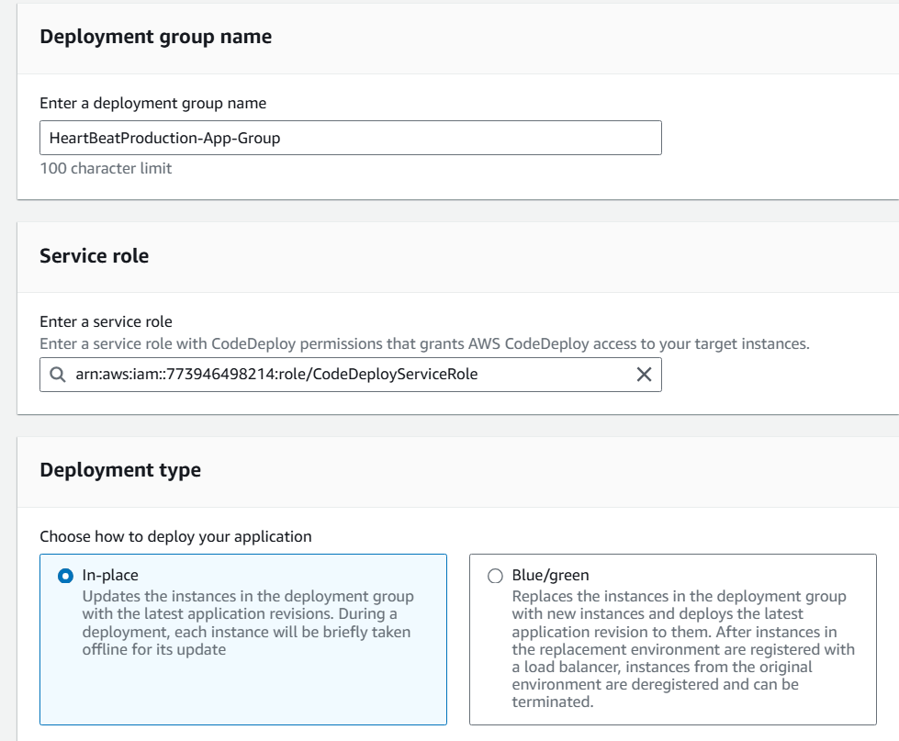

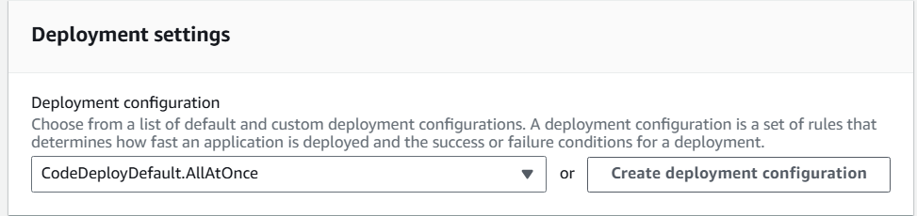

Click on Create Group

Objective 5 - Review the application bundle

5.1 Open Cloud9 using the URL given, and choose the speccified file

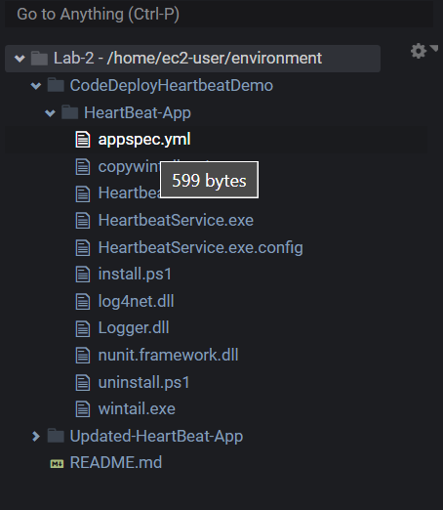

5.2 Review the file

| Expected | Actual |
| --- | --- |

Verified

Objective 6 - Deploying the Bundle

6.1 Run the following code in terminal



6.2 Deploy the application to CodeDeploy Targets

Run the following two commands

in second command: push the revision to the S3 bucket that you created in the previous step, and register the information with CodeDeploy



6.3 To deploy the application revision from the Amazon S3 bucket that you created earlier to the target (Amazon EC2) instances, run the following command:

This command creates a deployment associated with the following using the application revision named HeartBeat-App.zip in the Amazon S3 bucket that you created earlier:

* Application named CodeDeploy-Demo
* Deployment configuration named CodeDeployDefault.AllAtOnce
* Deployment group named HeartBeat-Deployment



Objective 7 - Monitor Deployment Status

7.1 Go to Cloud9 Dashboard, and search and select CodeDeploy

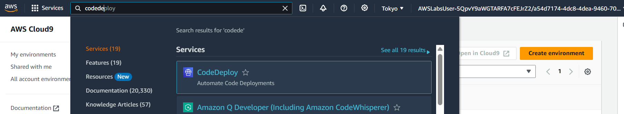

7.2 Match the deployment id and select that deployment

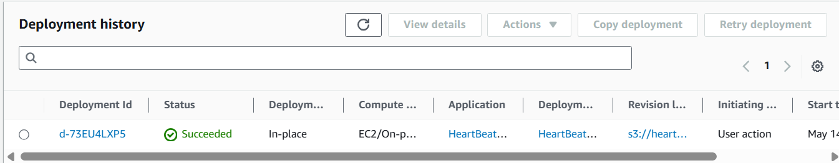

7.3 Two deployment id for two Heartbeat Applications

Both of them have a status of ***In Progress***. This is because you used the deployment configuration ***CodeDeployDefault.AllAtOnce*** in your CLI call. This instructs CodeDeploy to deploy the update to all servers at the same time.

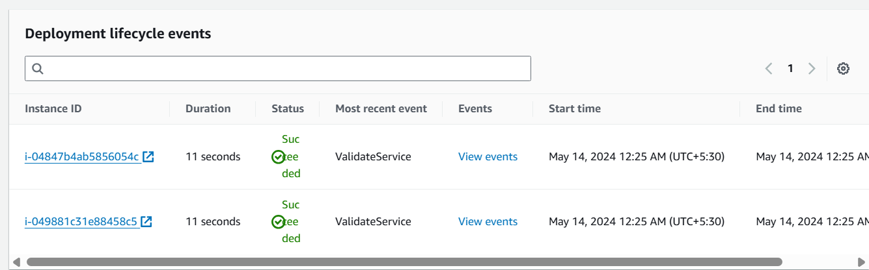

7.4 Success in Deployment of the two EC2 instances

7.5 Open EC2 Instances, and connect to Heartbeat Instance

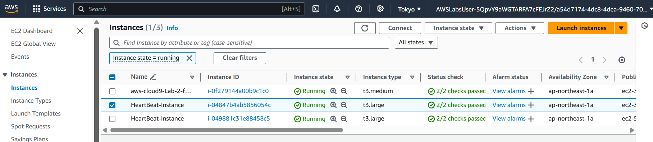

7.6 Run “Service “AWSHeartbeat*”” in CLI

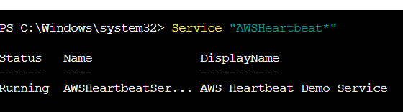

Shows the service as running

Similarly can verify for second instance too (from step 7.5)